**[Reportage Properties](https://reportageuae.com/" \t "_blank)**

About Reportage

[Reportage Properties](https://reportageuae.com/), a leading real estate developer with over 22 years of experience in the United Arab Emirates, is expanding its reach into the Egyptian market with the launch of Reportage Egypt in New Cairo.

This strategic move allows the company to bring its dedication to innovation and excellence in property development directly to Egypt, offering a diverse range of apartments and townhouses designed to meet the needs of discerning residents.

Our new venture aims to establish lasting relationships with both homeowners and investors seeking premium properties in Egypt. With our extensive experience and deep understanding of the local real estate landscape, we are confident in our ability to guide you toward your ideal property investment.

Our team is dedicated to providing a personalized and customer-centric approach, ensuring that your real estate journey is seamless and rewarding. We invite you to partner with us and explore the exciting opportunities that New Cairo's real estate market has to offer.

**Why we do it**

Our aim is to provide innovative, modern, and affordable housing solutions by developing and delivering property in Abu Dhabi and Dubai that offer our investors outstanding value. Reportage Group focuses on timely delivery and creating homes with unrivaled standards of living to establish a brand you can rely on.

**What we offer**

Reportage Group provides consistency by being built on a foundation of partnerships that optimize results, keeping all necessary activities ‘in-house’; from land assessment, to land acquisition, to planning, to architectural designing and construction with highly effective management teams overseeing the diverse project portfolio.

**Vision**

To be one of the most trusted real estate developers in the UAE and be highly regarded locally and internationally in the years to come.

**Mission**

To work with purpose and skillfully develop real estate projects that make investing a possibility for any budget. Reportage Properties aims to improve and continuously drive stakeholder value.

**Values**

Quality and excellence in everything we do.

Commitment to providing the best housing solutions

Practicality by effectively collaborating with one another to drive results

Creativity, innovation, and continuous improvement that shape our future

Executive Management

[Mr. Aref Al Khoori Chairman – Reportage Group](https://reportageeg.com/en/about-us" \l "pop43)

[Mr. Andrea Nucera Group Managing Director](https://reportageeg.com/en/about-us" \l "pop833)

[Mr. Giovanni Nucera Group International CEO](https://reportageeg.com/en/about-us" \l "pop1251)

[Dr. Ahmed Tantawy CEO of Reportage Egypt](https://reportageeg.com/en/about-us" \l "pop1266)

Projects in cairo

**Montenapoleone**

Beauty speaks Italian!

In partnership with Al Ahly Sabbour, we are pleased to introduce our first project on Egyptian lands as Reportage Egypt, and in one of the most sought-after locations, Mostakbal City – The new heart of New Cairo. ​ Montenapoleone, inspired by the renowned fashion street in Milan, represents a microcosm of Italy, and a reflection of Italian beauty on Egyptian lands. Spanning over an area of approximately 465.000 m2, the project incorporates a wide range of high-end residential and commercial areas, within 62% open spaces, to offer you the best of what a vibrant life has to offer.

**Montenapoleone .. Beauty speaks Italian!**

The residential area incorporates a number of 374 townhouses and multiple residential buildings that offer simplex and duplex units with various sizes ranging between 1B, 2B, 3B, and 4B apartments, and private gardens for selected units. The contemporary designs, modern facades, and high-quality finishing speak of Italian beauty and set the standards for high-quality living, offering a masterpiece to call home.

**Location**

Located in Mostakbal City. Its prime location in the heart of New Cairo, makes the Montenapoleone compound only

- 7 minutes far from Sixty Iconic Tower

- 10 minutes away from The New Ministerial District, Downtown New Capital and Madinaty

- 15 minutes from Cairo International Airport and El Sherouk City

- 16 minutes to New Capital Airport

- 20 minutes far from El Rehab City and AUC campus

**Exteriors**

With Italian design, modern facades, and earth colors, Montenapoleone stands out as a masterpiece of elegance and synchronicity. Contemporary, yet fitting and well-blending in the surrounding greenery and open spaces. In a perfect application of the design method of mass and void, frames on each elevation add an incomparable aesthetic touch.

Each building consists of three main parts:

Basement – Typical Floor – Cap/Roof and Rooftop Pool

The high-quality facades and double-glazed glass harmoniously work together to welcome sunlight, air, and all the serenity of nature into your little heaven. Each and every detail is well-thought-of to meet the tastes and needs of all types of residents and set the standard for functionality and high-quality living.

[[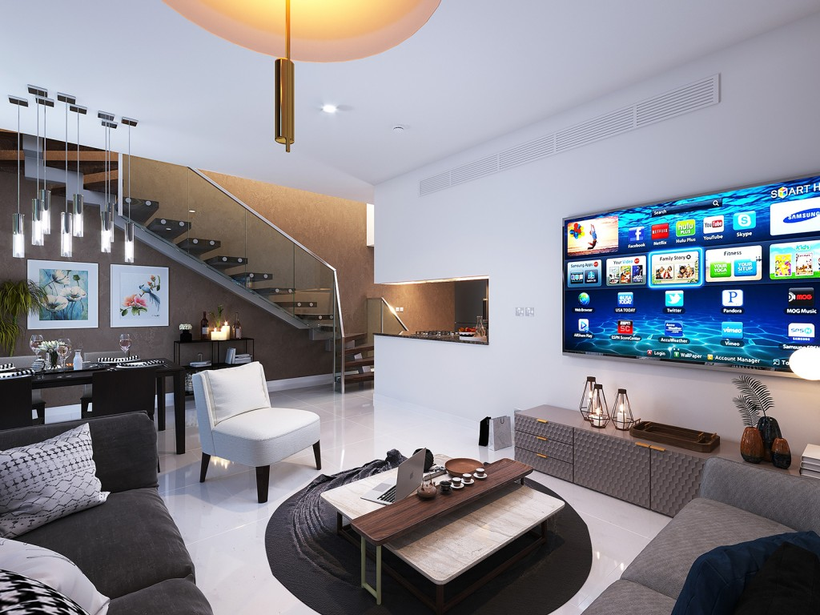](https://reportageeg.com/storage/post/HX3zgsk4CClsVI1cStVYdjP4tblYEJFt6Qtac5On.jpg)](https://reportageeg.com/storage/post/HX3zgsk4CClsVI1cStVYdjP4tblYEJFt6Qtac5On.jpg)

[[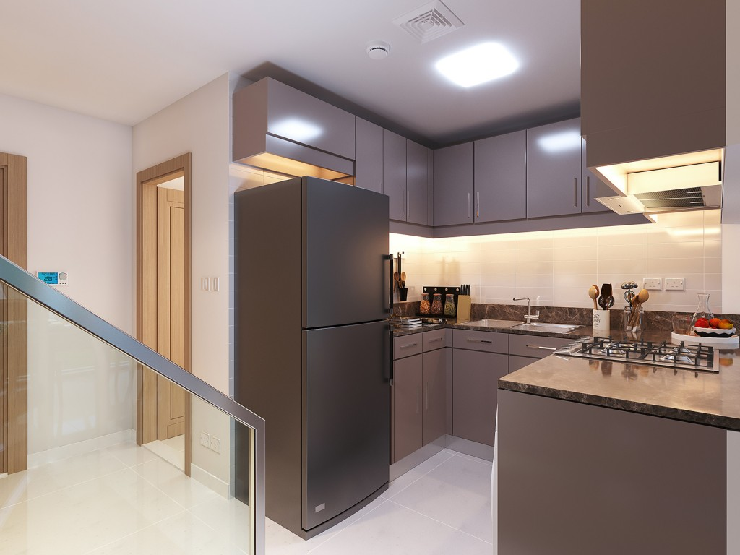](https://reportageeg.com/storage/post/MuSs2ZSIUWduEw7rqpVn43HvJTL2hEUPDAiys8eM.jpg)](https://reportageeg.com/storage/post/MuSs2ZSIUWduEw7rqpVn43HvJTL2hEUPDAiys8eM.jpg)

[[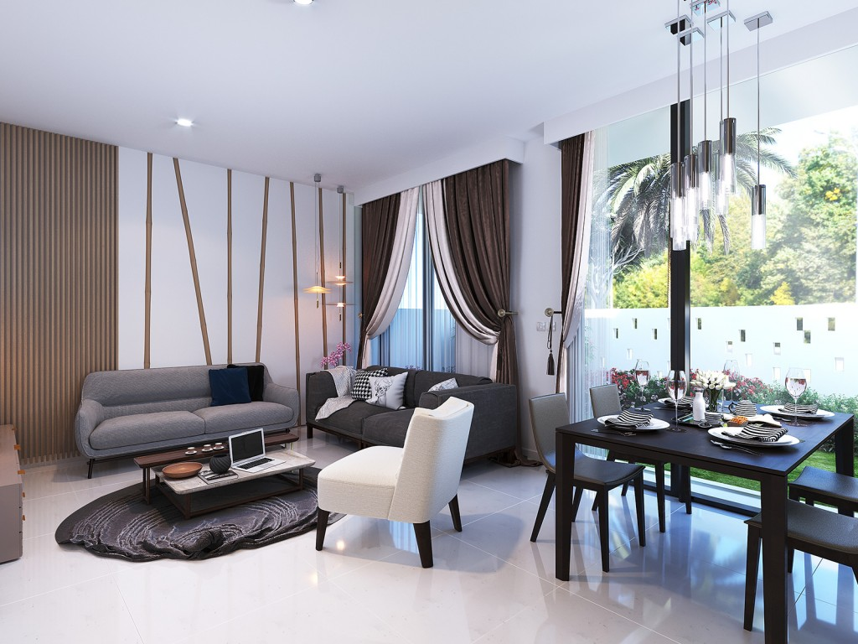](https://reportageeg.com/storage/post/DvzJPAFgYllSltFt5A4ge9RA8ISnqGOnrSby5hDh.jpg)](https://reportageeg.com/storage/post/DvzJPAFgYllSltFt5A4ge9RA8ISnqGOnrSby5hDh.jpg)

[[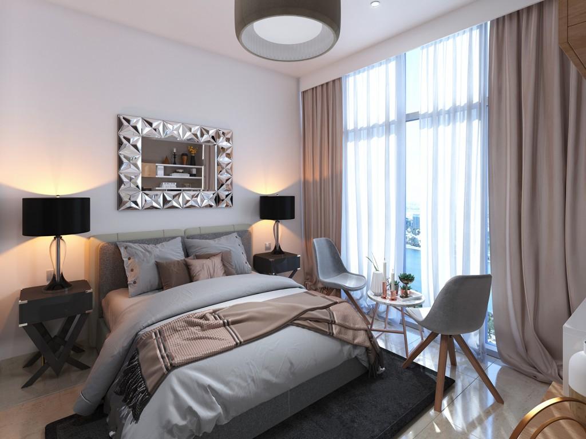](https://reportageeg.com/storage/post/vXPSiIl4w0Ome1Bw8lwb8CYLYM2h5D9RMGfLWgEm.jpg)](https://reportageeg.com/storage/post/vXPSiIl4w0Ome1Bw8lwb8CYLYM2h5D9RMGfLWgEm.jpg)

[[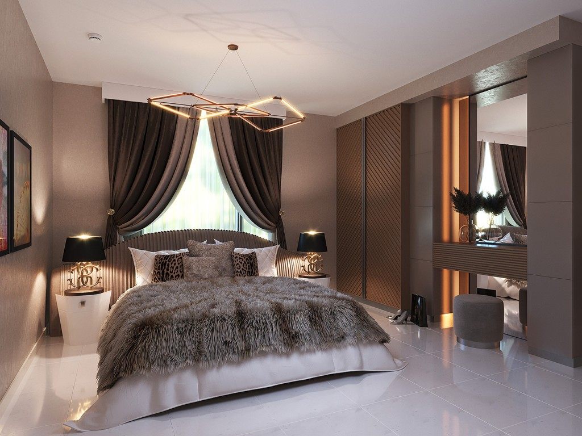](https://reportageeg.com/storage/post/nfBchjnDlzP6w48ffiCjAhQVtq2h2LuiZXk30v2a.jpg)](https://reportageeg.com/storage/post/nfBchjnDlzP6w48ffiCjAhQVtq2h2LuiZXk30v2a.jpg)

[[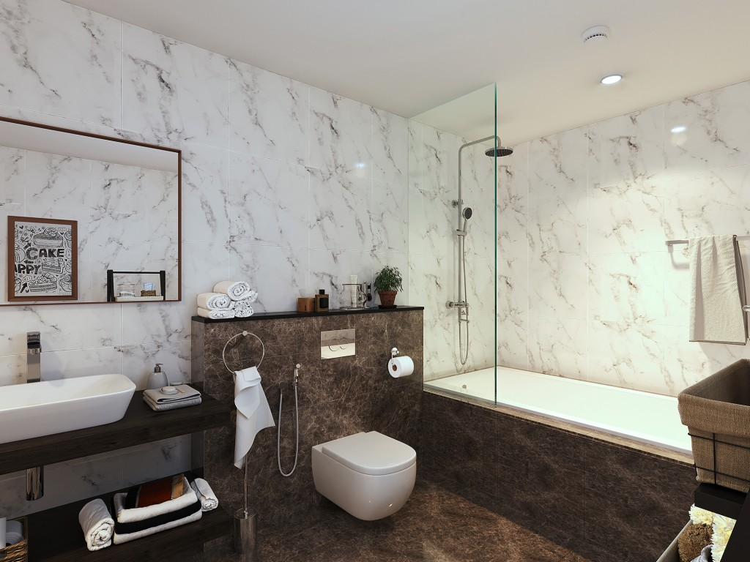](https://reportageeg.com/storage/post/si4PBohHZhJi5Xvm9suqZLkiChfDfHV5yH8h6kSq.jpg)](https://reportageeg.com/storage/post/si4PBohHZhJi5Xvm9suqZLkiChfDfHV5yH8h6kSq.jpg)

[[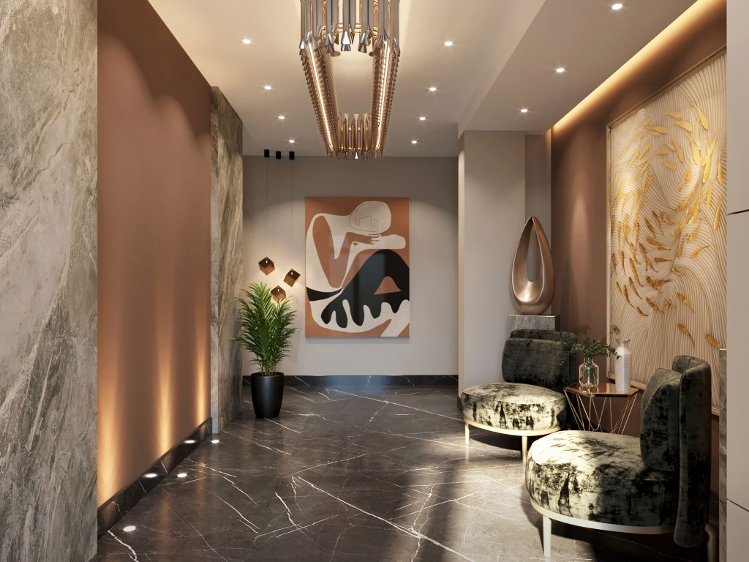](https://reportageeg.com/storage/post/eixkKtweHoFtRrCT72UOGZndQjCeUaWpiN2pyyuU.jpg)](https://reportageeg.com/storage/post/eixkKtweHoFtRrCT72UOGZndQjCeUaWpiN2pyyuU.jpg)

[[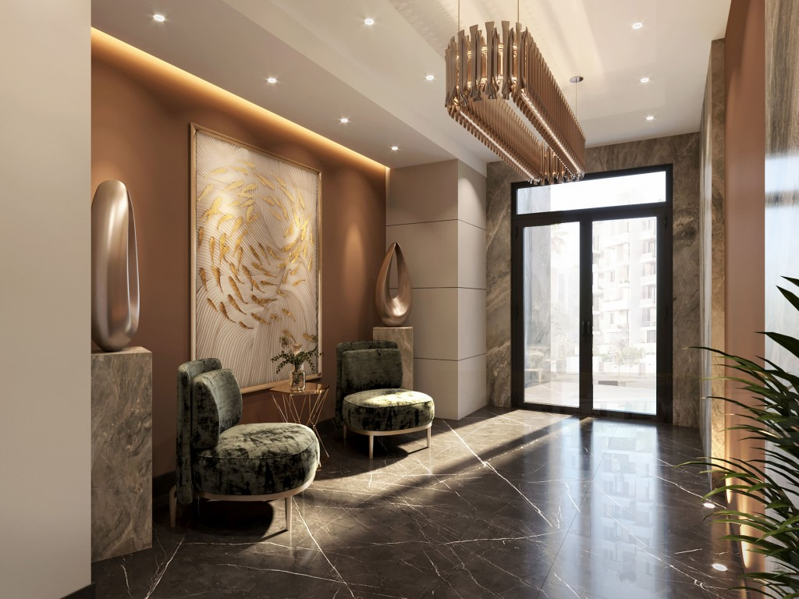](https://reportageeg.com/storage/post/fdWhubLOT0g9SoTAGbNjbBwup9RDUkjmErnze0kb.jpg)](https://reportageeg.com/storage/post/fdWhubLOT0g9SoTAGbNjbBwup9RDUkjmErnze0kb.jpg)

[[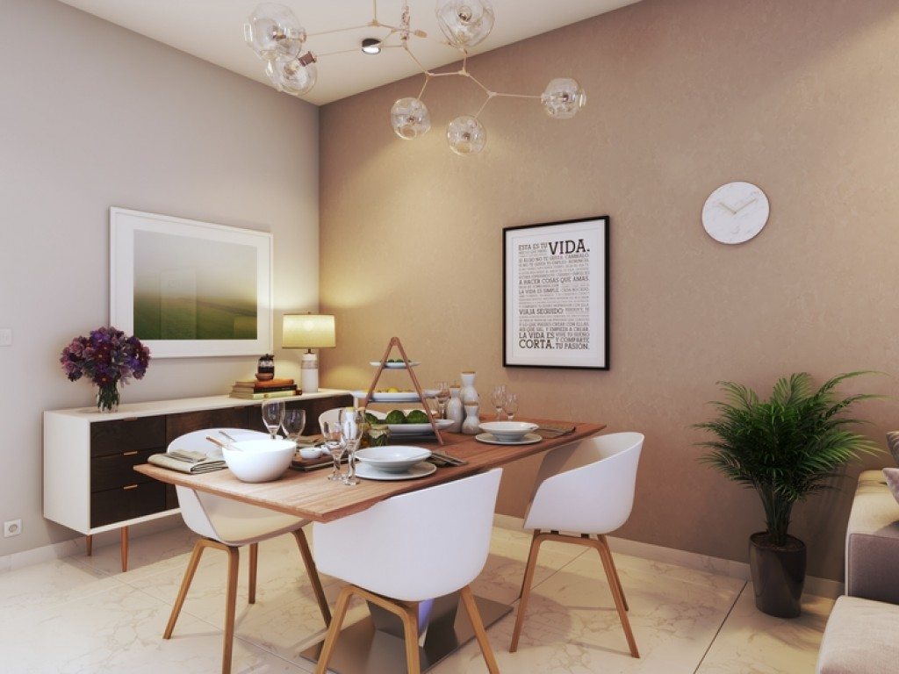](https://reportageeg.com/storage/post/T8JeFl2Qp8DUGrsWpaCUF7Xg2fNycP9k7PhsCZho.jpg)](https://reportageeg.com/storage/post/T8JeFl2Qp8DUGrsWpaCUF7Xg2fNycP9k7PhsCZho.jpg)

[[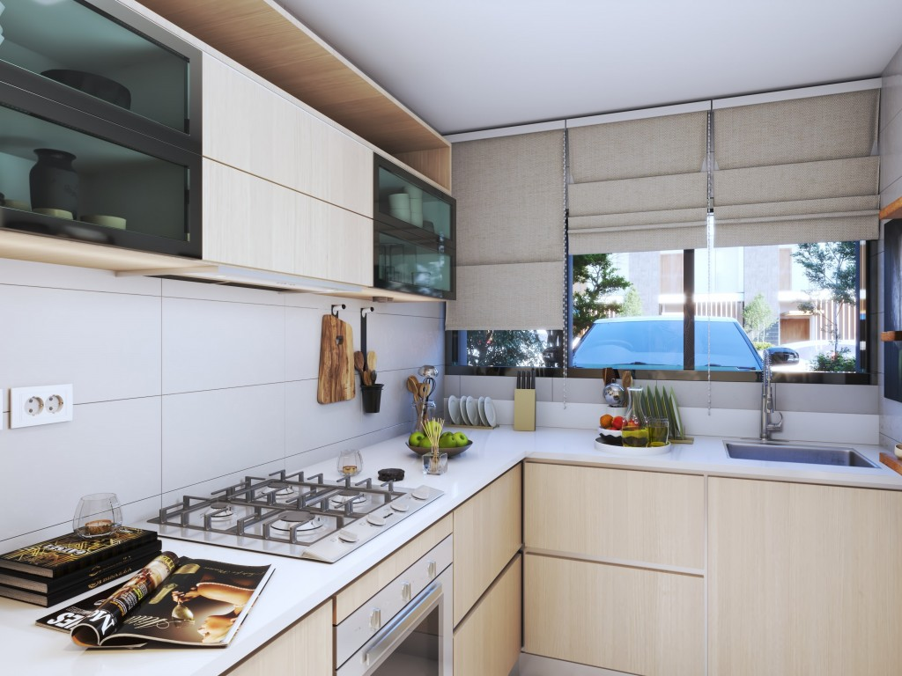](https://reportageeg.com/storage/post/VvYyUVbiGwTnrVQNn827R8F9TJfPO8tHVJyIx5JK.jpg)](https://reportageeg.com/storage/post/VvYyUVbiGwTnrVQNn827R8F9TJfPO8tHVJyIx5JK.jpg)

[[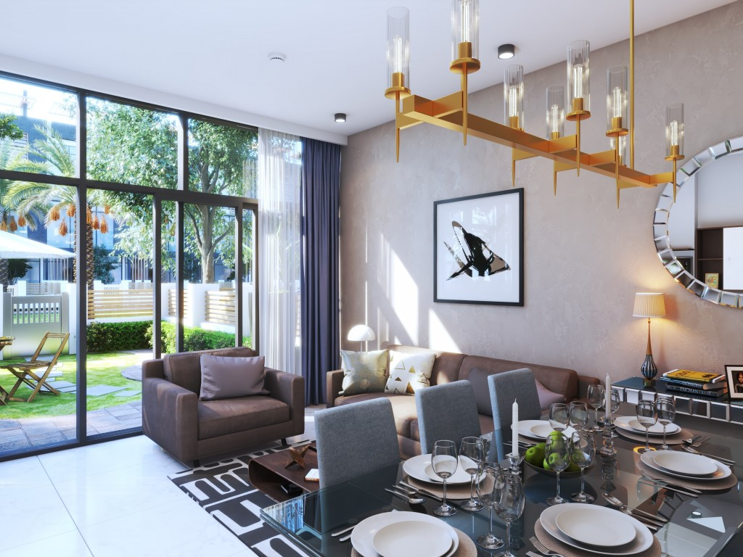](https://reportageeg.com/storage/post/3atTn6tBgTooYGvf2d5I3PSwmTiYsZmmSPHlQJHQ.jpg)](https://reportageeg.com/storage/post/3atTn6tBgTooYGvf2d5I3PSwmTiYsZmmSPHlQJHQ.jpg)

[[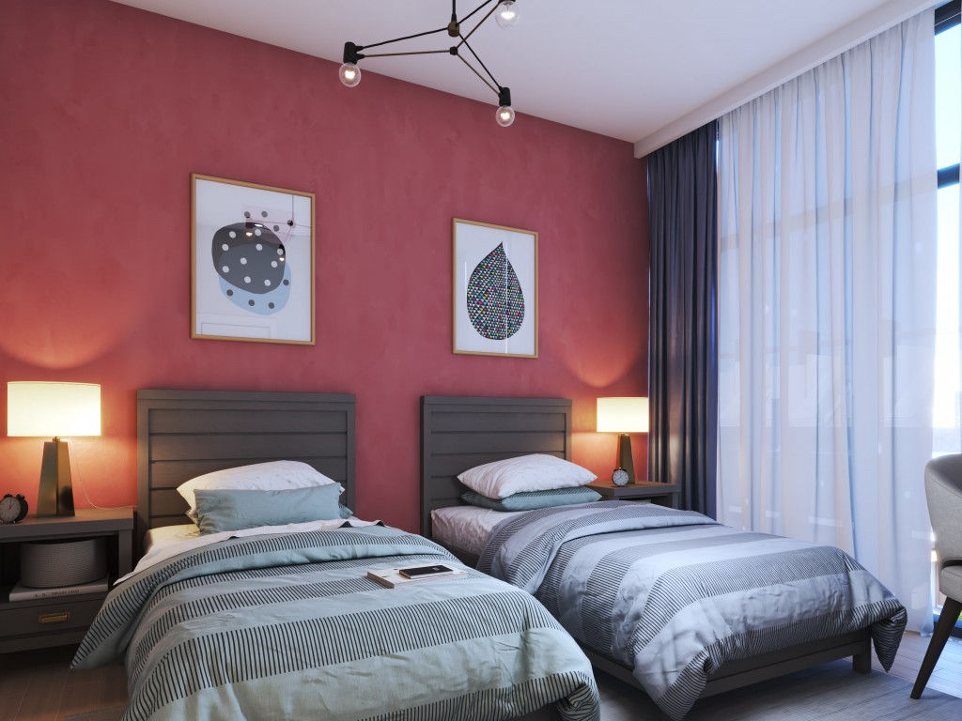](https://reportageeg.com/storage/post/HDoxwI4rc6EYel27AIT3afm8rsrD2hMQ4Oxvo6Te.jpg)](https://reportageeg.com/storage/post/HDoxwI4rc6EYel27AIT3afm8rsrD2hMQ4Oxvo6Te.jpg)

[[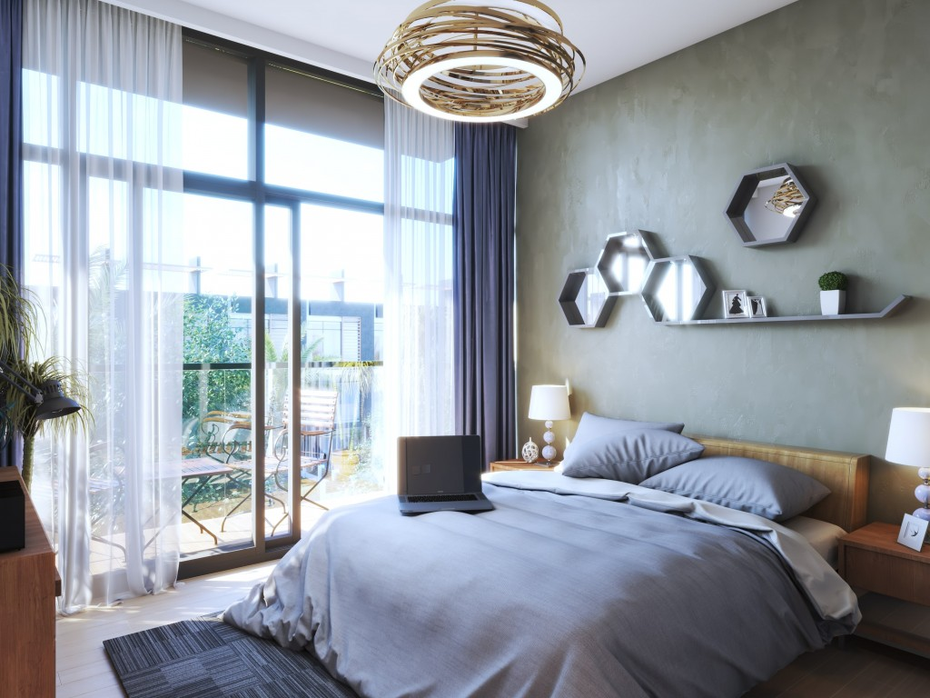](https://reportageeg.com/storage/post/xJWnXc8c7T0TO2eitXeYL2EqqCsUDy3EPhyj1dZY.jpg)](https://reportageeg.com/storage/post/xJWnXc8c7T0TO2eitXeYL2EqqCsUDy3EPhyj1dZY.jpg)

[[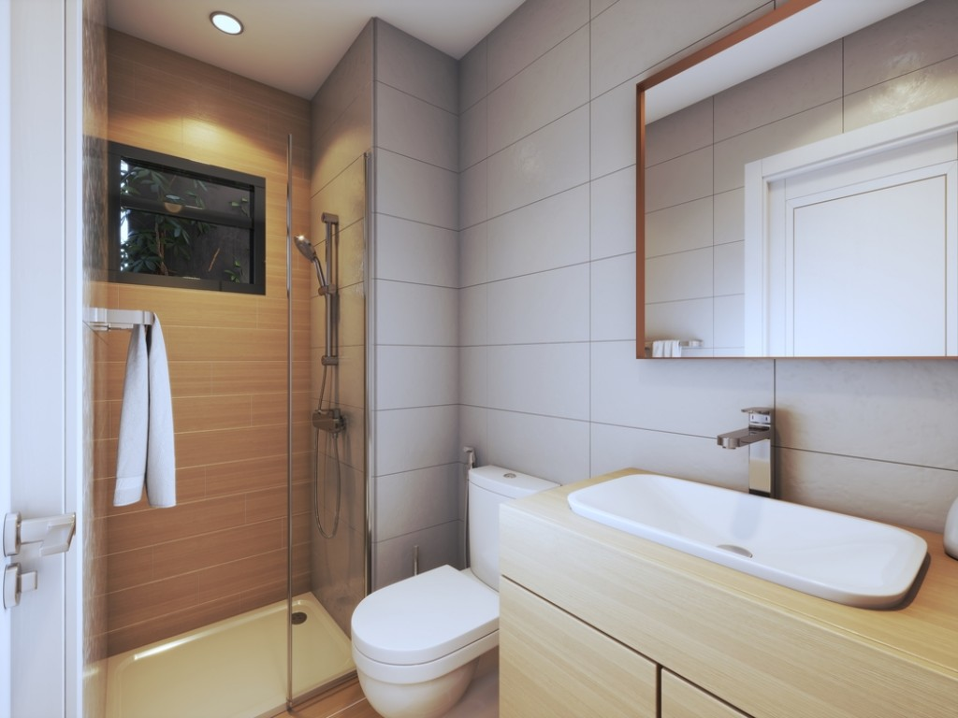](https://reportageeg.com/storage/post/EB43qQYBhLl4qmNsfAx8SAyTNI13wJjOzLqgAqU4.jpg)](https://reportageeg.com/storage/post/EB43qQYBhLl4qmNsfAx8SAyTNI13wJjOzLqgAqU4.jpg)

[[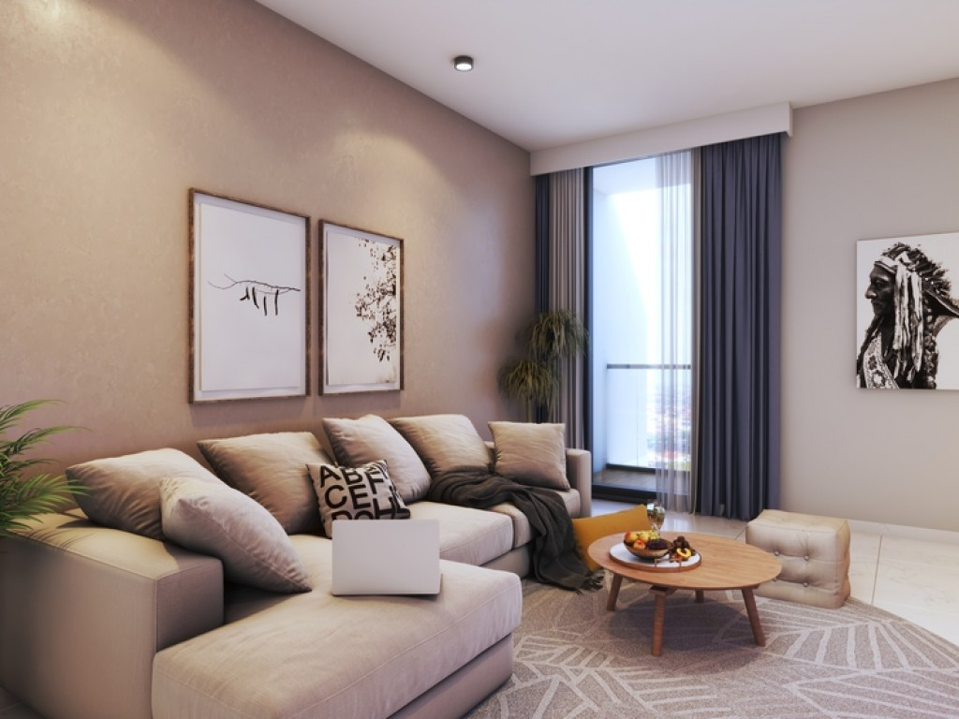](https://reportageeg.com/storage/post/GuuLnRqRxlWaUnqFD5fCBbOOtaE1XAc5uTkGbQ28.jpg)](https://reportageeg.com/storage/post/GuuLnRqRxlWaUnqFD5fCBbOOtaE1XAc5uTkGbQ28.jpg)

[[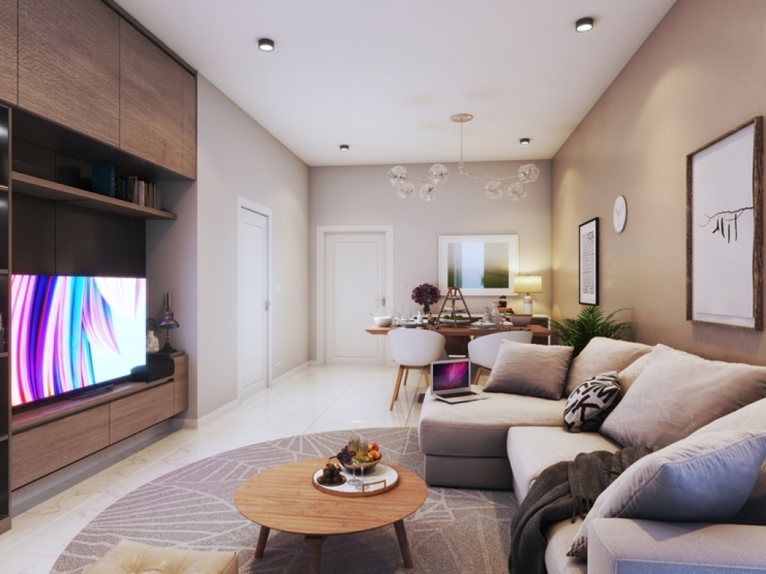](https://reportageeg.com/storage/post/nFB86QsjFn6f6eaVpjFGYW2GyJXKCYhQctfezZL7.jpg)](https://reportageeg.com/storage/post/nFB86QsjFn6f6eaVpjFGYW2GyJXKCYhQctfezZL7.jpg)

[[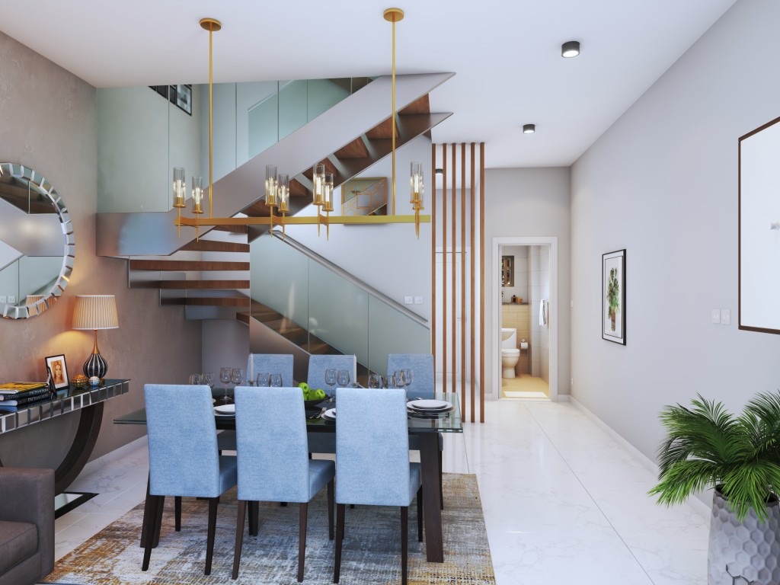](https://reportageeg.com/storage/post/itzVlAYsNe3HcngDBJPOvMhtutPHQj8H1yj3Y936.jpg)](https://reportageeg.com/storage/post/itzVlAYsNe3HcngDBJPOvMhtutPHQj8H1yj3Y936.jpg)

**Interiors**

Designed to fit all the needs and every refined taste, Montenapoleone's modern Italian designs never fail to impress. From the high-quality finishing and the neutral color palette to the perfectly designed divisions, every detail is well thought of and a masterpiece on its own. Air and sunlight always find their way to your little heaven and balconies and terraces will never leave you unenergized. Whether a family home or a bachelor’s, Montenapoleone will always offer you the life you aspire for.

Kitchens and Bathrooms are never a small detail; they are perfectly designed to meet your expectations of functionality and refined taste. All kitchens are equipped with kitchen cabinets and scratch-free countertops, and bathrooms, whether en-suites or guest bathrooms are fully tiled with high-quality finishing, bathtubs, and showers.

**Amenities**

Swimming Pool

Gym

Playground

Football Court

Shopping Center

Mosque

Property Types in Montenapoleone: townhouses and multiple apartment buildings including duplex units and apartments.